WEB DEVELOPMENT ACTIVITY-BASED LEARNING PROJECT REPORT
A comprehensive documentation of front-end web design projects developed using HTML5 and CSS3
- NAME: M. Bhavani
- BRANCH: CSE
- SECTION: 1
Prepared by M. Bhavani
Introduction
This report serves as a formal compilation of three distinct website projects developed as part of the Web Development Activity-Based Learning curriculum. The core objective of this academic exercise is to transition theoretical knowledge of front-end development into functional, user-centric web interfaces.
Throughout these implementations, significant emphasis has been placed on semantic HTML structure, modern CSS styling methodologies (such as Flexbox and Grid), responsive design principles, and intuitive user navigation. Each project models a real-world web application domain, offering interactive front-end layouts complete with forms, structured cards, and polished visual hierarchies.
Project Overview Table
Case No. | Assigned Project Category | Developed Website Title
1 | Personal Portfolio Website | M. Bhavani - Professional Portfolio
10 | Real Estate Property Listing Website | Bhavani Estates & Properties
30 | Bus and Train Ticket Booking Interface | Voyage Transit Hub
Case No. 1
Personal Portfolio Website
Website name: M. Bhavani - Professional Portfolio
Detailed Explanation
The Personal Portfolio Website is meticulously structured to serve as a digital resume and professional showcase. Designed with a sleek, minimalist aesthetic, it effectively highlights personal branding, academic credentials in Computer Science and Engineering, technical proficiencies, project milestones, and contact channels.
The architecture of the page utilizes semantic HTML5 landmarks (<header>, <section>, <article>, <footer>) to ensure optimal accessibility and code readability. On the styling front, CSS3 features such as custom variables, smooth transitions, media queries for mobile responsiveness, and flexible container layouts were implemented to ensure seamless viewing across desktop, tablet, and mobile devices. Interactive navigation anchors allow users to effortlessly jump between distinct profile sections.
Output Screenshots
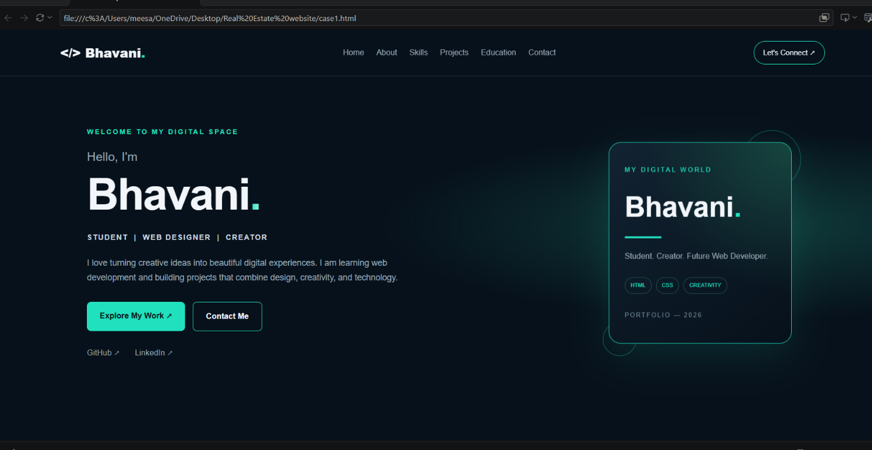

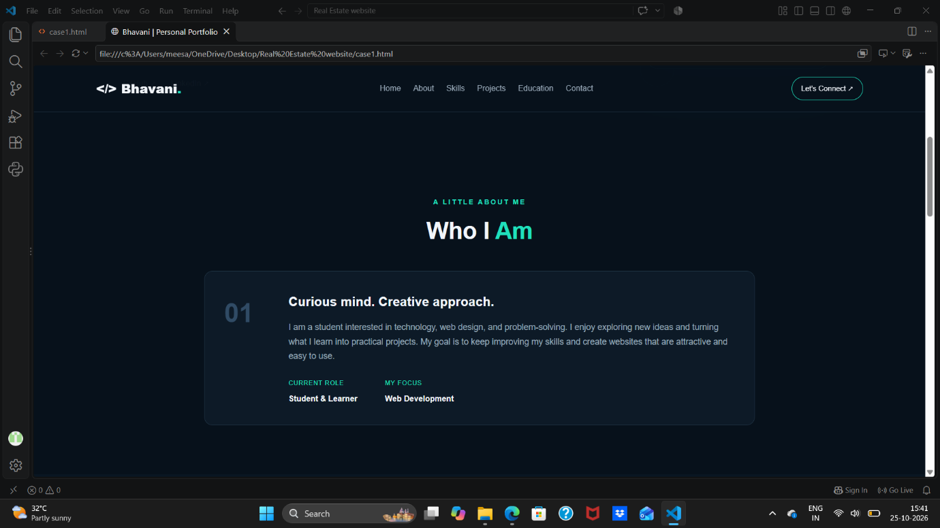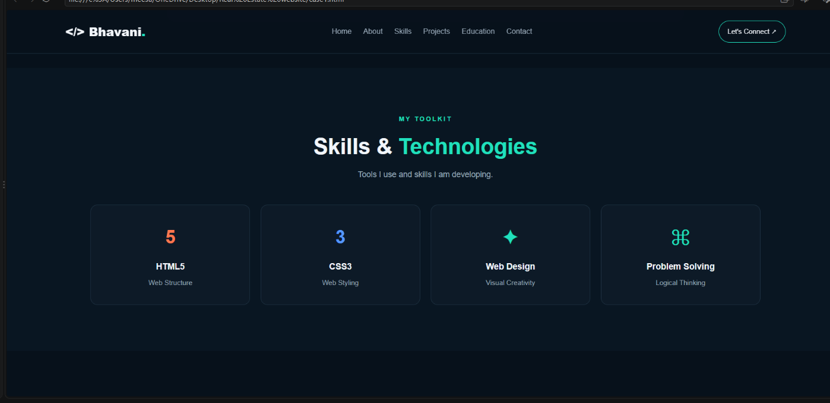
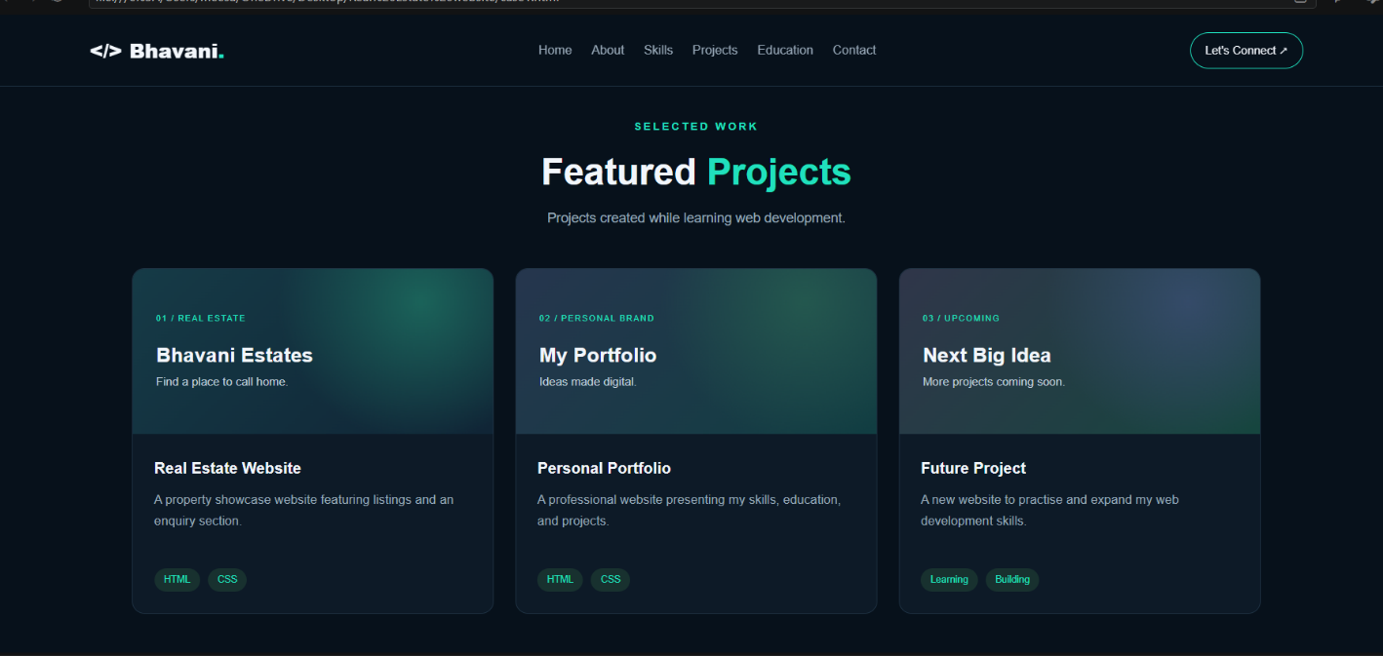
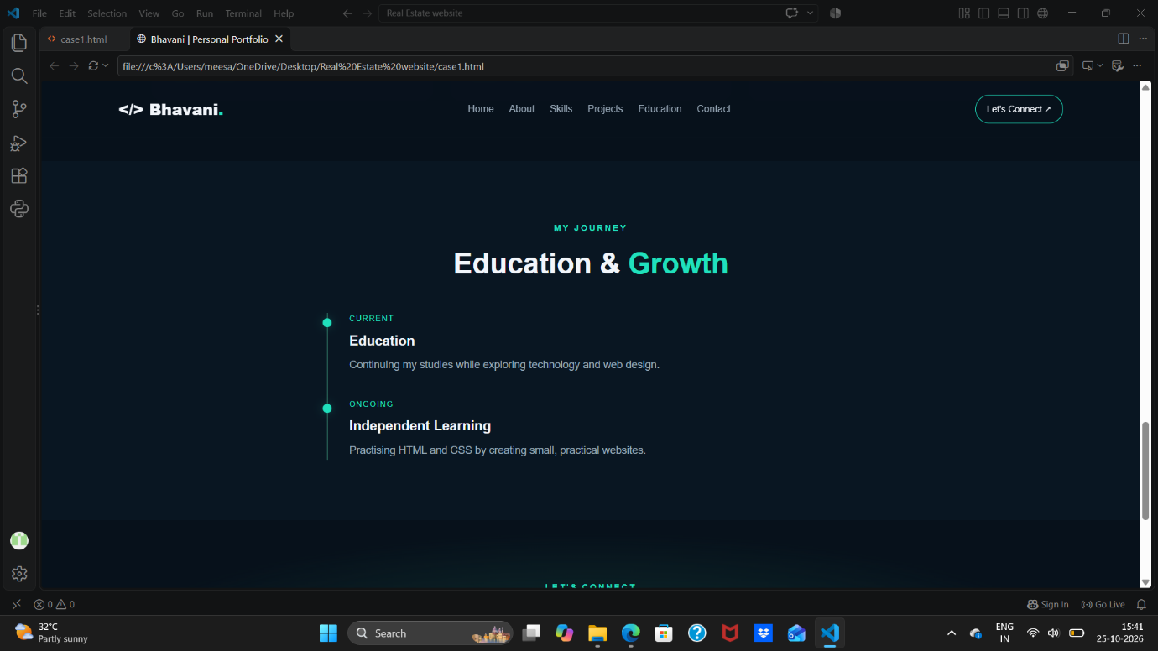

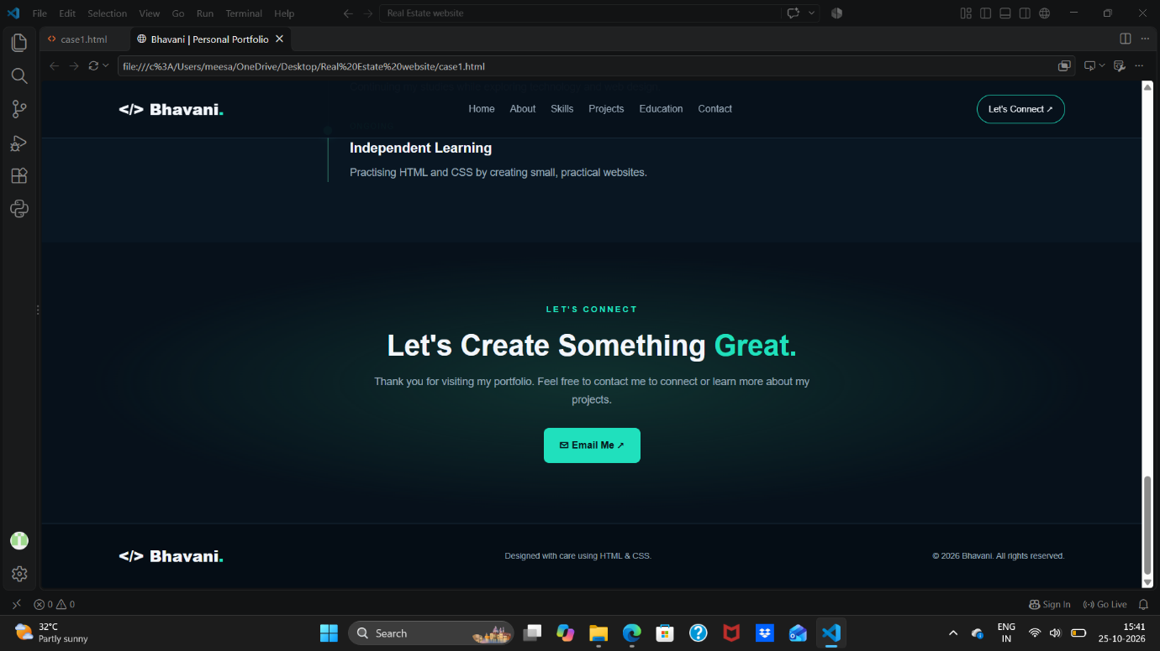

Case No. 10
Real Estate Property Listing Website
Website name: Bhavani Estates & Properties
Detailed Explanation
The Real Estate Property Listing Website is engineered to simulate a modern property marketplace where users can explore houses, apartments, and commercial rentals. The system organizes complex property data into clean, structured visual cards displaying pricing, geographical location, key amenities, and high-level descriptions.
To maximize usability, the interface integrates a dedicated search and filter component layout, allowing potential clients to sort property options based on specific criteria. CSS Grid and Flexbox were heavily utilized to build balanced, multi-column property grids that dynamically adapt to varying screen resolutions, ensuring a polished and professional user experience.
Output Screenshots
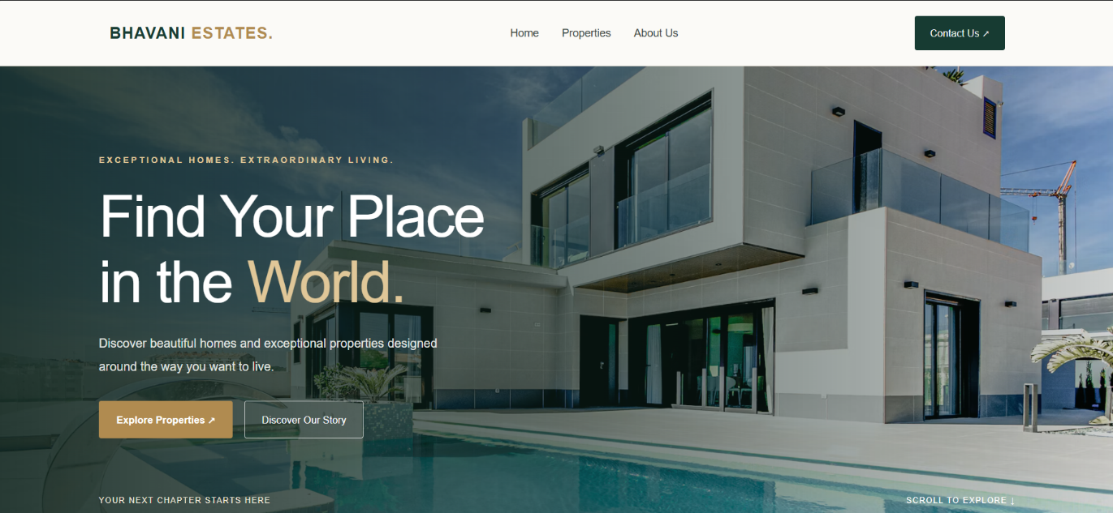
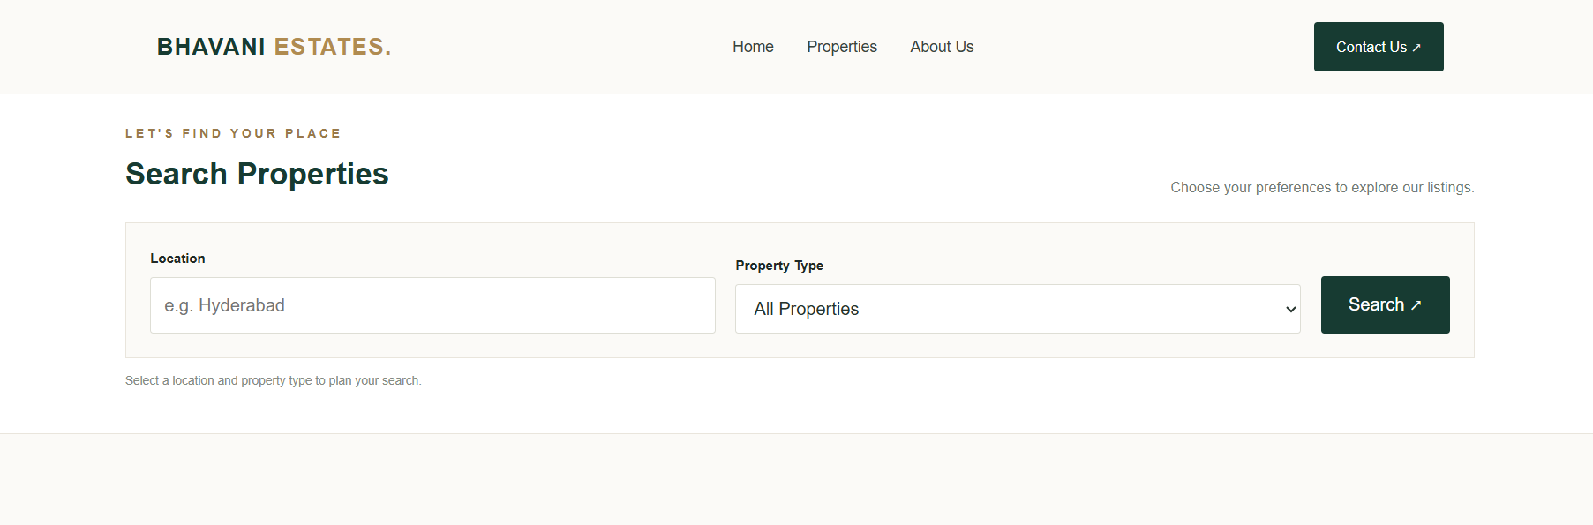
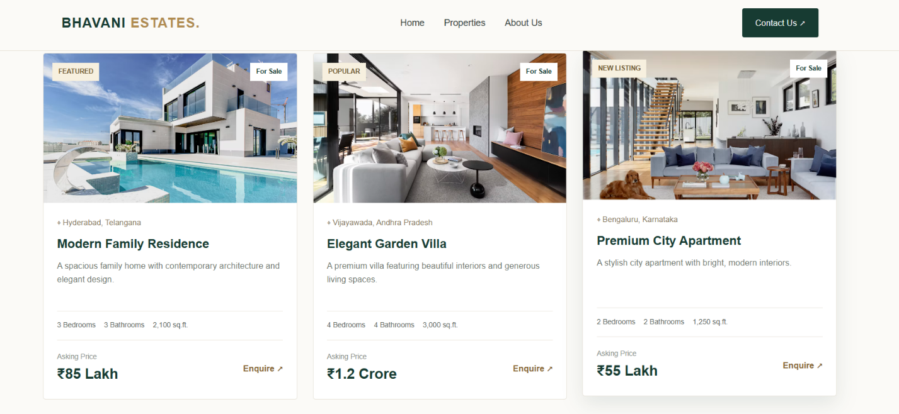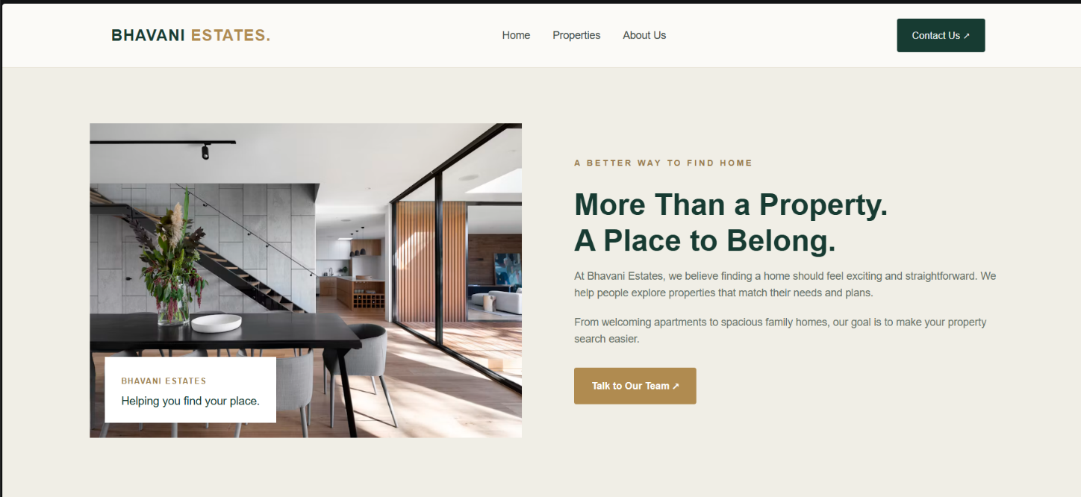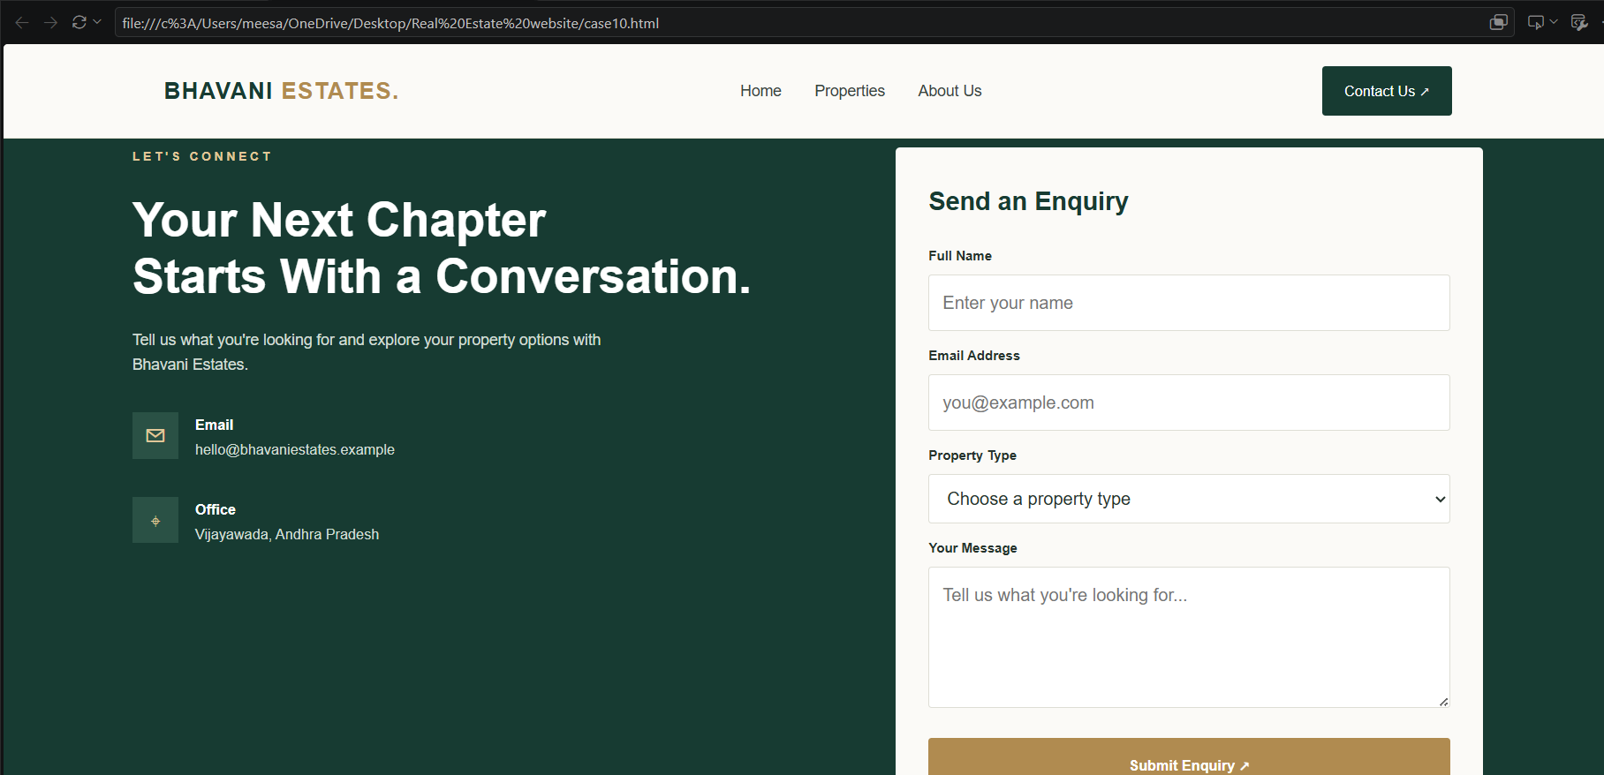

Case No. 30
Bus and Train Ticket Booking Interface
Website name: Voyage Transit Hub
Detailed Explanation
Voyage Transit Hub is a comprehensive travel reservation interface designed to simplify how users search and evaluate bus and train transportation routes. The primary design focus centers on information clarity, allowing travelers to review departure times, transit durations, operator details, and fare structures efficiently.
The page layout incorporates an advanced booking search panel featuring form controls for source and destination inputs, calendar selection, and passenger count tracking. Structured data tables and responsive travel cards present available transit options clearly. The visual styling adopts a cohesive color palette, clear typographic scale, and robust responsive rules to maintain aesthetic integrity on smaller viewports.

Output Screenshots

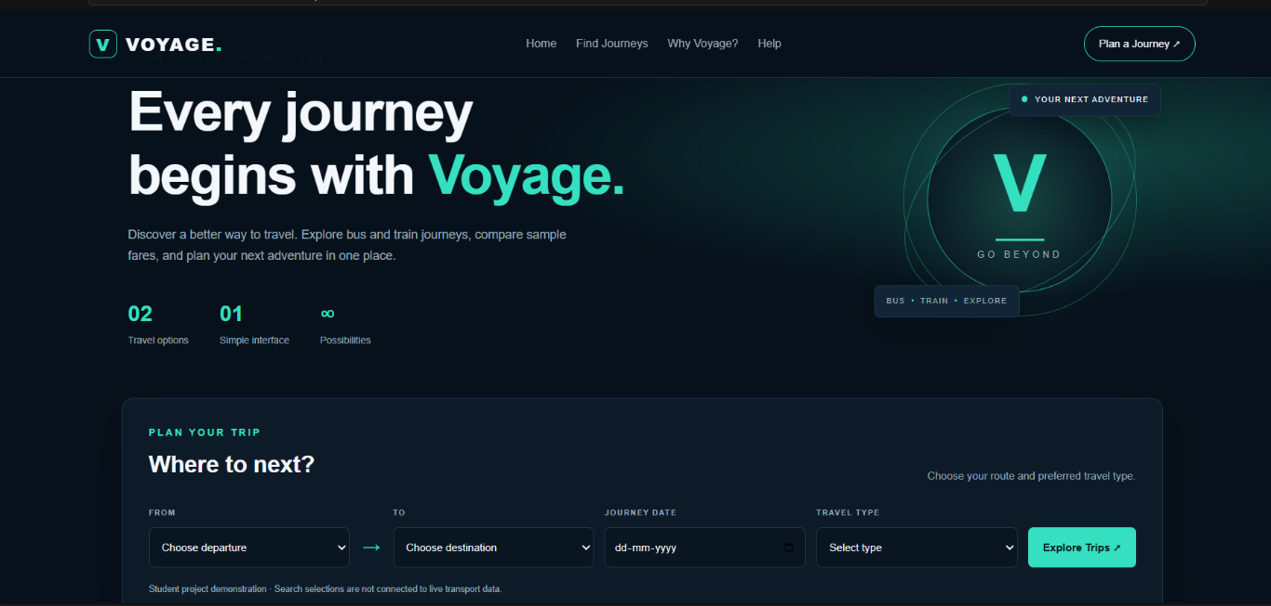

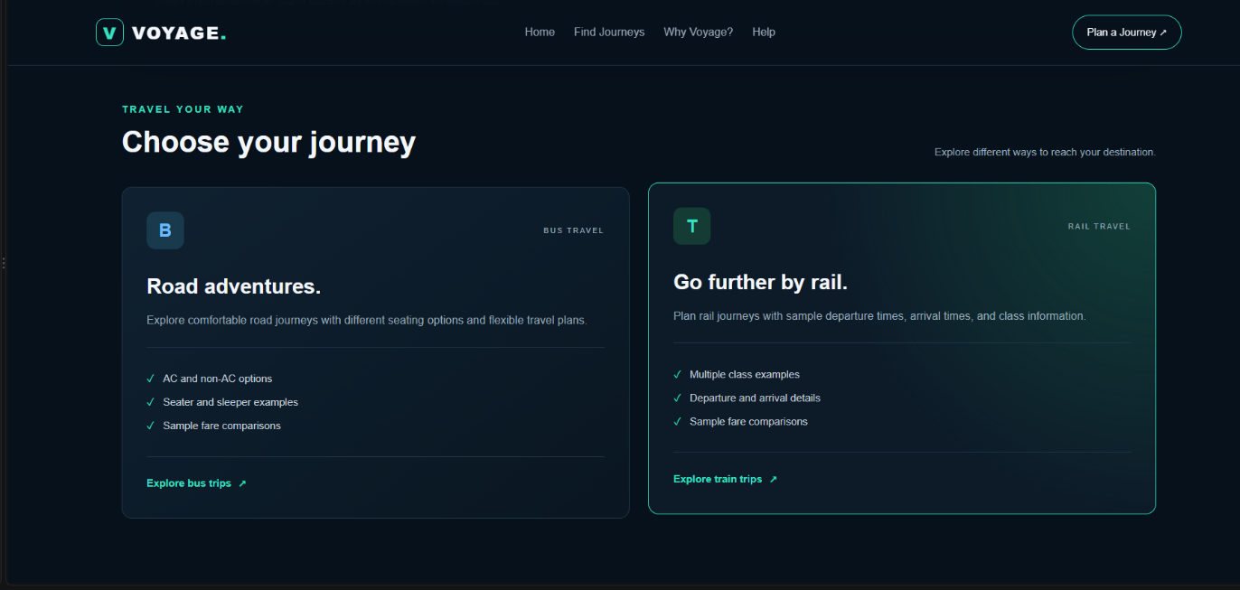
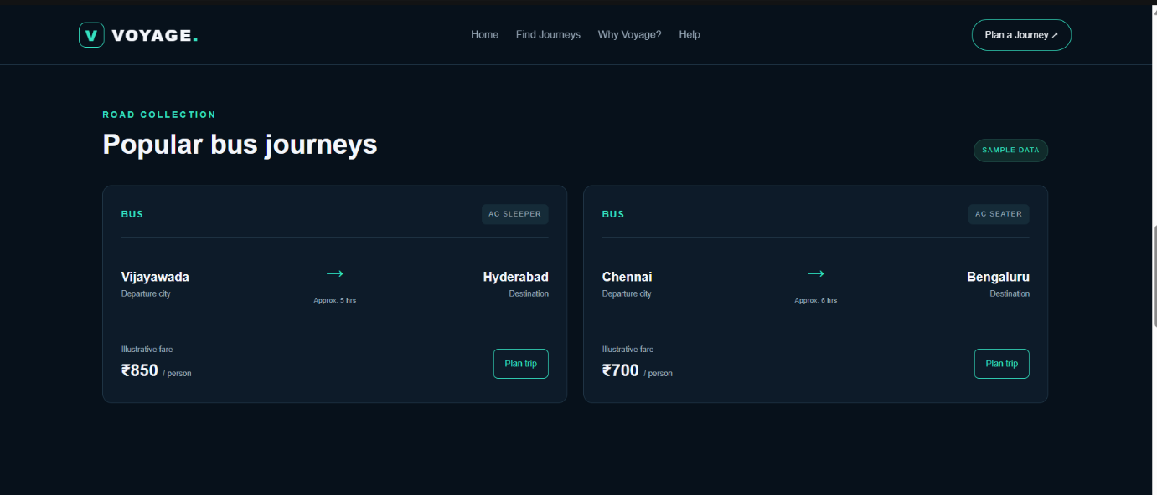
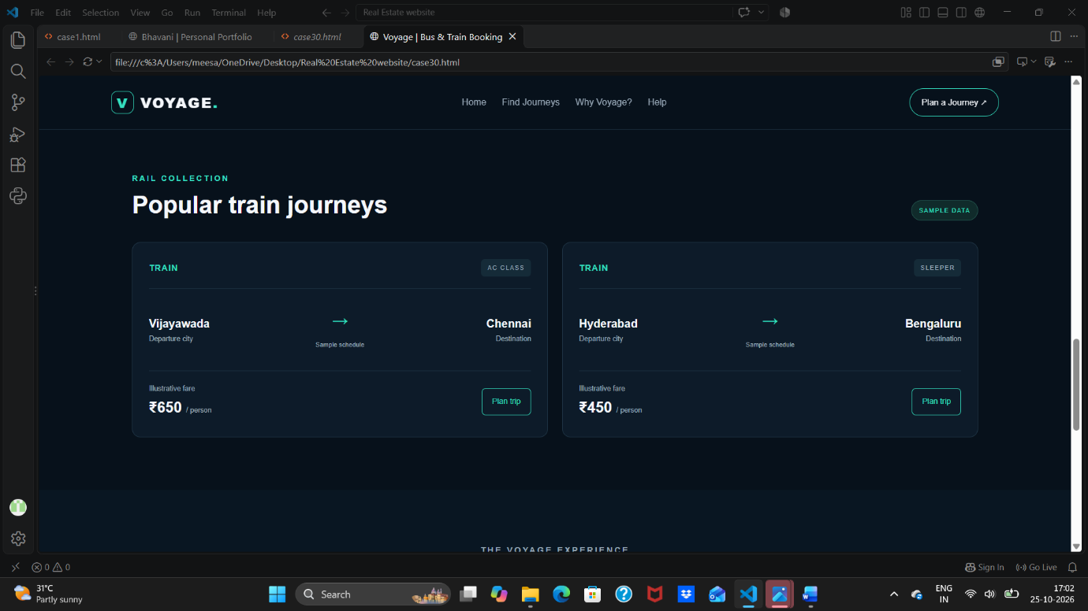
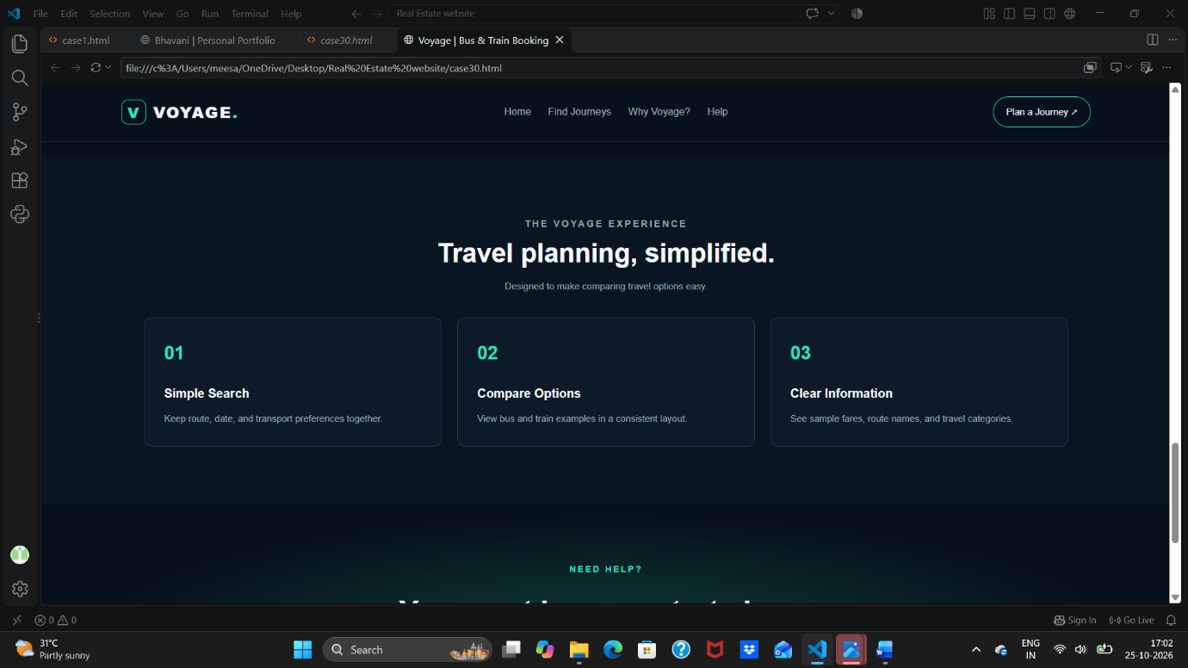

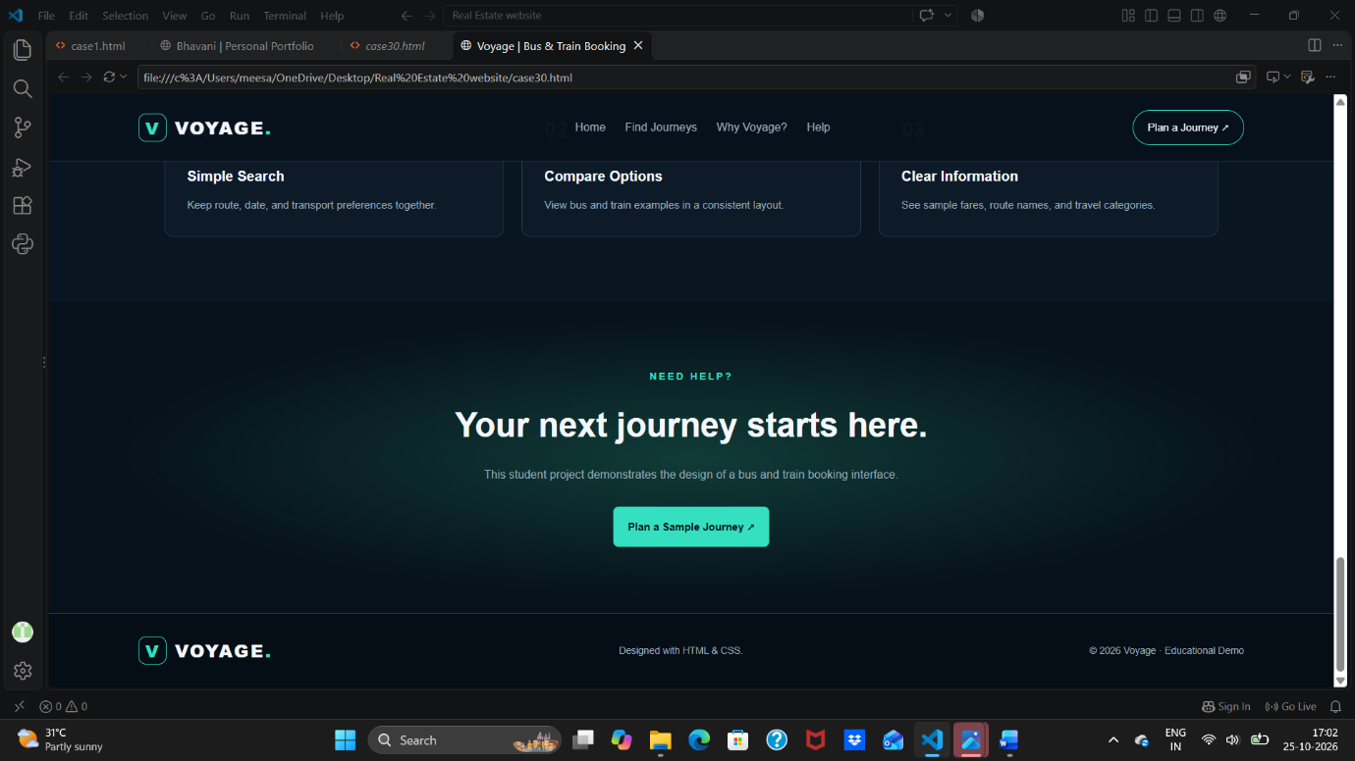

Conclusion
The completion of these three distinct web projects has provided deep practical insights into modern front-end development workflows. By leveraging HTML5 for content architecture and CSS3 for visual presentation, this activity reinforced critical web engineering concepts including responsive design, UI consistency, grid alignment, and semantic markup composition.
These projects successfully demonstrate how specialized web interfaces—ranging from individual portfolios to large-scale booking and listing systems—can be structured to deliver optimal user engagement and functional clarity.

Submitted by
- Name: M. Bhavani
- Branch: CSE
- Section: 1

